FOUNDATIONS OF DATA SCIENCE

Assignment

Project Tittle: **SUSTAINABLE SUPPLY CHAIN** PERFOMANCE **DASHBOARD** USING **POWER BI**

## Objective:

The objective of this report is to analyze and visualize the **supply chain data** using **Power BI** in order to gain valuable insights into the efficiency and performance of the supply chain operations. This report aims to:

1. Identify key trends and patterns within the supply chain data.
2. Highlight areas for improvement in supply chain processes.
3. Provide actionable recommendations based on data-driven insights.
4. Demonstrate the capability of Power BI as a powerful tool for data **analysis and visualization**.

## Data Collection:

**T**he data used in this project was obtained from a **GitHub repository** in **CSV** file format. It includes various details relevant to supply chain operations, such as **order information, delivery times, product data, and supplier details**.

## Data Variables

1. Product Type: Category of the product.
2. SKU (Stock Keeping Unit): Unique identifier for each product.
3. Price: Cost of the product.
4. Availability: Status of the product's availability.
5. Number of Orders: Total number of orders for the product.
6. Revenue: Total revenue generated by the product.
7. Customer Rating: Average customer rating for the product.
8. Stock Level: Current inventory level of the product.
9. Lead Time: Time taken to restock the product.
10. Order Quantity: Quantity of the product ordered.
11. Shipping Time: Time taken to ship the product.
12. Shipping Cost: Cost of shipping the product.
13. Shipping Carrier: Name of the shipping carrier.
14. Supplier ID: Unique identifier for each supplier.
15. Supplier Location: Geographical location of the supplier.
16. Lead Time (Supplier): Time taken by the supplier to deliver the product.
17. Production Cost: Cost of producing the product.
18. Manufacturing Date: Date of product manufacture.
19. Manufacturing Location: Location where the product was manufactured.
20. Inspection Status: Status of product inspection.
21. Defect Rate: Percentage of defective products.
22. Transportation Mode: Mode of transportation used for delivery.
23. Routes: Delivery routes taken.
24. Transportation Costs: Costs associated with transportation.

These variables provide detailed information about the products, orders, suppliers, and logistics involved in the supply chain. Analyzing these variables helps in understanding the efficiency and performance of the supply chain operations

## Data Cleaning:

In this project, several data cleaning steps were undertaken to ensure the accuracy and reliability of the analysis:

1. **Missing Values**: Identified and handled any missing values by either filling them with relevant data or removing the incomplete records.
2. **Duplicates**: Removed any duplicate records to avoid redundancy.
3. **Inconsistencies**: Corrected inconsistencies in data formats, such as date and time formats, to ensure uniformity.
4. **Outliers**: Identified and addressed outliers that could skew the analysis results.
5. **Data Types**: Checked and converted data types as necessary to ensure proper formatting for analysis.
6. **Standardization**: Standardized categorical variables for consistency.

These steps helped improve the quality of the dataset, ensuring more accurate and meanin

## Data Exploration:

The goal was to understand the supply chain data and find patterns. Here's what we did:

1. **Descriptive Statistics:**
   * Calculated basic stats (mean, median, etc.) to understand the data.
   * Found the minimum, maximum, and average values for key variables.
2. **Visualization:**
   * **Histograms:** Showed how numerical data is spread out.
   * **Box Plots:** Helped identify data spread and outliers.
   * **Bar Charts:** Displayed the frequency of categories.
3. **Correlation Analysis:**
   * Checked if any numerical variables were strongly related.
4. **Trend Analysis:**
   * Looked for patterns over time in the data.
5. **Anomaly Detection:**
   * Identified any unusual data patterns.

## Data Transformation

1. **Scaling**: Converted all measurements to the same unit.
2. **Encoding**: Turned categories into numbers.
3. **New Features**: Made new variables from existing ones.
4. **Summarizing**: Combined data to see patterns.
5. **Converting Types**: Fixed data types.
6. **Filling Gaps**: Filled missing values.

By doing these steps, your data is ready for analysis.

**Dashboard Description**

The Power BI dashboard we created provides a comprehensive overview of key supply chain metrics and insights. The dashboard is organized into various sections, each focusing on different aspects of the supply chain operations.

1. **Summary Metrics**:
   * **Total Orders**: Displays the total number of orders processed.
   * **Total Revenue**: Shows the total revenue generated from all orders.
   * **Average Delivery Time**: Highlights the average time taken for deliveries.
   * **Defect Rate**: Indicates the percentage of defective products.
2. **Product Analysis**:
   * **Revenue by Product Type**: A bar chart showing the revenue generated by different product categories such as skincare, haircare, and cosmetics.
   * **Top Products**: A list or table of the top-selling products based on revenue and order quantity.
   * **Stock Levels**: A bar chart displaying the current inventory levels of various products.
3. **Supplier Performance**:
   * **Supplier Ratings**: A bar chart or table showing the average ratings of different suppliers.
   * **Delivery Time by Supplier**: A line chart displaying the average delivery times for each supplier.
   * **Defect Rate by Supplier**: A bar chart highlighting the defect rates associated with different suppliers.
4. **Shipping and Logistics**:
   * **Shipping Times**: A line chart or bar chart showing the average shipping times for different shipping carriers.
   * **Shipping Costs**: A table or bar chart displaying the shipping costs associated with different shipping methods.
   * **Transportation Modes**: A pie chart showing the distribution of various transportation modes used for delivery.
5. **Geographical Insights**:
   * **Sales by Region**: A map visualization showing the distribution of sales across different geographical regions.
   * **Supplier Locations**: A map highlighting the locations of all active suppliers.
6. **Quality Control**:
   * **Defect Rates**: A pie chart or bar chart showing the defect rates for different product categories.

Each section of the dashboard is designed to provide clear and actionable insights into the supply chain operations. The visualizations help users quickly identify trends, patterns, and areas for improvement, enabling data-driven decision-making.

## Dashboard Description

**Dashboard Overview**: The Power BI dashboard provides a comprehensive overview of key supply chain metrics. It is organized into sections such as Summary Metrics, Product Analysis, Supplier Performance, Shipping and Logistics, Geographical Insights, and Quality Control.

**Key Metrics**:

* **Total Orders**
* **Total Revenue**
* **Average Delivery Time**
* **Defect Rate**

**Visualizations**:

* **Revenue by Product Type**: A bar chart showing revenue for different product categories.
* **Top Products**: A list of the top-selling products.
* **Stock Levels**: A bar chart of current inventory levels.
* **Supplier Ratings**: A table of supplier ratings.
* **Delivery Time by Supplier**: A line chart showing delivery times.
* **Defect Rate by Supplier**: A bar chart of defect rates.
* **Shipping Times**: A line chart of average shipping times.
* **Shipping Costs**: A table of shipping costs.
* **Transportation Modes**: A pie chart of transportation modes.
* **Sales by Region**: A map visualization of sales distribution.
* **Supplier Locations**: A map of supplier locations.
* **Defect Rates**: A pie chart of defect rates by product category.

## Analysis and Insights

**Data Analysis**: Trend analysis, correlation analysis, and anomaly detection techniques were used to analyze the supply chain data.

**Findings**: The key findings and insights derived from the dashboard include:

* Identification of top-performing products and regions.
* Analysis of supplier performance and defect rates.
* Insights into shipping and logistics costs and times.

**Interpretation**: The findings indicate areas for improvement in supplier performance, inventory management, and logistics operations.

Dashboard: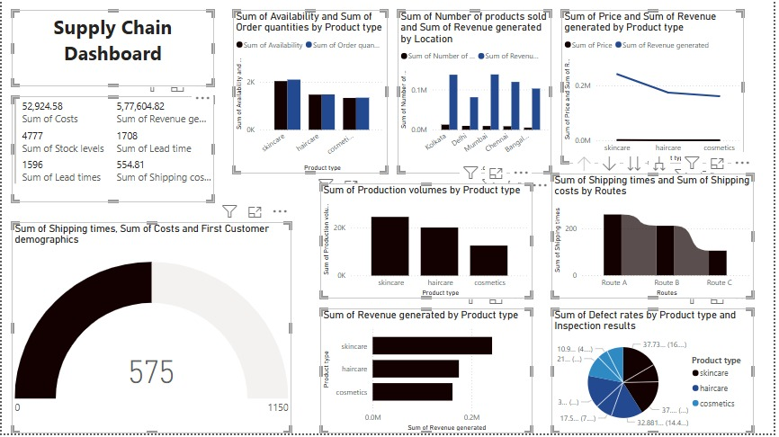

## Conclusion and Recommendations

**Summary**: This report analyzed supply chain data and visualized key metrics using a Power BI dashboard.

**Recommendations**:

* Optimize supplier selection based on performance and defect rates.
* Improve inventory management to reduce stockouts and excess inventory.
* Enhance shipping and logistics efficiency to reduce costs and delivery times.

**Future Work**: Future work could involve incorporating real-time data updates, adding more advanced analytics, and expanding the dashboard to include additional supply chain metrics.

Github Links:

Vincymol :https://github.com/vuvincymol/supply-chain-dashboard.git

Submitted to:

Miss Nancy louise

Submitted by

2nd year AI & DS

Vincy Mol V U

Sarathi U

Brahmendra Takellapati